2026

Land and Water Conservation Fund grant application guide


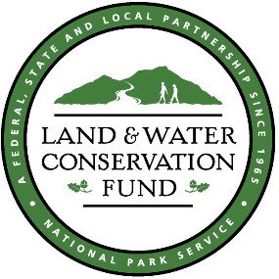
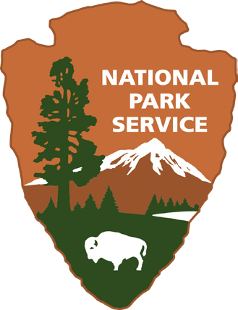

OKLAHOMA TOURISM AND RECREATION DEPARTMENT FEDERAL GRANTS SECTION

123 ROBERT S. KERR SUITE 900 OKLAHOMA CITY, OKLAHOMA 73102-6406

Preface
This guide will provide the Land and Water Conservation Fund applicant (project sponsor) with the instructions and necessary to prepare and submit a complete application.
Project sponsors must provide all requested information in this application and guide to be considered for funding; therefore, it is important to read all items carefully. A checklist is included in the Appendix to help ensure project sponsors have met all requirements.
Project applicants must upload their application and supplemental information to the OTRD online file storage system. After completing your application, please send a request to grants@travelok.com, and a link will be provided. Once you receive your link, you can upload, delete, or edit any information in your application folder until the application deadline at 4:00 P.M. on March 31st, 2026.
The last day to request your link is 4:00 PM on March 24, 2026.
Applications must be uploaded to the online file storage system by 4:00 PM on March 31, 2026.

Contact Information
OTRD Grants
Grants@travelok.com
Rhonda Moore | Federal Programs Manager
Rhonda.Moore@travelok.com 405.522.9522
Thank you for your interest in the Land and Water Conservation Fund program. Please contact us with any questions or for assistance with the application process.

Land and Water Conservation Fund

Program Summary
The Land and Water Conservation Fund (LWCF) is a federal assistance program administered by the National Park Service (NPS) at the federal level. The NPS provides the LWCF matching grants to the States, and through the States to local governments, for the acquisition and development of public outdoor recreation areas and facilities.

Income for the LWCF is provided largely from Outer Continental Shelf (OCS) mineral receipts. In 2020, the Great American Outdoors Act (Public Law 116-152) made annual disbursement from the LWCF mandatory. Amounts for State Assistance from the LWCF are supplemented by a mandatory amount set aside each year in a special Treasury account from other qualified offshore revenues pursuant to the Gulf of Mexico Energy Security Act of 2006 (Public Law 109-432)

LWCF grants are provided to the States, and through the States to local governmental jurisdictions. In Oklahoma, the Oklahoma Tourism and Recreation Department administers the fund at the state level.

History and Purpose
The Land and Water Conservation Fund Act of 1965 was enacted “...to assist in preserving, developing, and assuring accessibility to all citizens of the United States of America of present and future generations...such quality and quantity of outdoor recreation resources as may be available and are necessary and desirable for individual active participation...”

Goals of the LWCF State Assistance Program are to:
- Meet state and locally identified public outdoor recreation resource needs to strengthen the health and vitality of the American People.
- Increase the number of protected state and local outdoor recreation resources and ensure their availability for public use in perpetuity.
- Encourage sound planning and long-term partnerships to expand the quantity and to ensure the quality of needed state and local outdoor recreation resources.

Statewide Comprehensive Outdoor Recreation Plan
In keeping with the law under the LWCF Act, the Oklahoma Tourism and Recreation Department coordinates the production of Oklahoma’s Statewide Comprehensive Outdoor Recreation Plan (SCORP). The SCORP is a study that evaluates the demand and supply of public outdoor recreation resources throughout the State.
The SCORP is used to identify priorities for acquiring, developing, and protecting all types of outdoor recreation resources and outdoor recreation programs throughout the State.
All proposed LWCF projects must meet priority outdoor recreation needs as identified in pages 12 and pages 40-43 of the current SCORP to be eligible for assistance.

The SCORP can be found online at:
Oklahoma’s Statewide Comprehensive Outdoor Recreation Plan (SCORP) - Oklahoma Tourism and Recreation Department (travelok.com)

An approved local Master Plan that shows a need for the requested recreational facility may take priority over the SCORP needs assessment.

Reimbursable Grant
The Land and Water Conservation Fund is a reimbursable grant, meaning the project sponsor must pay all project costs as they are incurred. Sponsors then may request reimbursement of 50% of eligible expenses up to the amount approved for the project. All costs must be incurred and paid by the project sponsor during the project period as identified in the approved Sponsor Agreement. There is not a funding cap, so an eligible sponsor may request as much funding as they are able to match.
Any project expenses incurred or paid by the sponsor before or after the project period will not be eligible for reimbursement or project match.

Types of Projects:
- Acquisition – There must be public access.
- Development – Must provide or support public outdoor recreation.
- Combination – Acquisition and Development.

All new facilities within the project boundary must conform to current ADA and ABA accessibility standards. It is best practice to update existing structures to meet accessibility standards.

Project Sponsor Commitment and Responsibility

Eligible Applications
Incorporated cities, counties, state agencies, tribal nations, and public universities are eligible to apply for Land and Water Conservation Funds for the acquisition and development of outdoor recreation projects. State Parks and statewide planning projects may also be funded.
All eligible project sponsors must be able to commit their resources to the perpetual stewardship of the LWCF-assisted public outdoor recreation area. All projects are required to conform to LWCF eligibility and evaluation criteria in LWCF Manual Chapter 3, Sections B and C.

Ownership and Control
If land acquisition is part of a project, the sponsor may not take title to the land or begin development until after both federal and state approval of the project. An appraisal of the property will be required.
For all development projects, the project sponsor must possess sufficient title and adequate legal control of the property. This will typically require the sponsor to hold fee-simple title to the property. However, ownership of less-than-fee interest may be acceptable if it provides for permanent control of the property to be utilized as an outdoor recreation area in perpetuity. Upon completion of the project, sponsors will be required to place a deed restriction upon the subject property, indicating federal assistance was provided, and preventing any sale or modification of the property without the approval of the Secretary of The Department of the Interior.

Permanent Outdoor Recreation Estate
The Land and Water Conservation Fund Act requires the sponsor to operate and maintain the properties or facilities acquired, developed, and/or renovated with LWCF assistance for public outdoor recreation use in perpetuity. As required by Section 6(f)(3) of the LWCF Act, should any portion of LWCF-assisted property be converted for anything other than public outdoor recreation use, the project sponsor must replace, at its own expense, the converted property with property having equal or greater appraised value and equal or greater recreational usefulness. Below is the language to include on property deeds that have been acquired or developed on with funding from the LWCF:
As stated in the LWCF Financial Assistance Manual, in accordance with 2 C.F.R. §200.316 and the LWCF General Provisions (Section II.F), the State or subrecipient must record a deed restriction or other appropriate notice of record in the public property records of the jurisdiction in which the park or recreation area is located. The notice should reference the grant agreement and include a copy of the boundary map to convey that the property described and shown in the scope of the project agreement and the signed and dated project boundary map made part of that agreement, has been acquired or developed with LWCF assistance and that it cannot be converted to other than public outdoor recreation use without the written approval of the Secretary of the Interior.

Operation and Maintenance
Property acquired or developed with LWCF assistance must be operated and maintained by the project sponsor according to certain federal and state standards. These responsibilities begin immediately upon completion of a project and will remain as such in perpetuity.
Beginning no later than five years from project completion, staff from the Oklahoma Tourism & Recreation Department will make periodic compliance inspections
(With or without notice).
Staff from the National Park Service may also conduct random inspections to ensure long-term stewardship.
Every application must contain a 5-year maintenance plan that includes anticipated needs and costs as well as available resources for operating and maintaining the project area.
Operation and Maintenance Guidelines are included in the Appendix.

Project Execution
The Oklahoma Tourism and Recreation Department encourages project sponsors to begin projects promptly following state and federal approval. It is important sponsors commit the necessary resources toward the project to ensure the facilities are available promptly to the public.
Failure of sponsors to initiate a project within a reasonable time may result in rescission of funds and termination of the project agreement.

Project Research and Planning

Public Participation
Project sponsors are required to obtain input from interested and affected public regarding recreation needs and proposed planning of the grant project. Public comments can be collected via survey, public meeting, or social media.
Applications must provide proof of notice and method for invitations to the public to participate in the planning of the proposal. In addition, project sponsors must provide comments via meeting minutes, survey results, or social media comments.
Project sponsors should attempt to develop a comprehensive project plan based on information and input received from the public. Public input will have an impact on how the project is scored.

Project Location
When determining the location for a project, project sponsors should choose an area suitable for the proposed recreation facilities as well as any support facilities that will serve the project area. The location should be free of adverse environmental factors that could minimize quality recreation or present a health or safety hazard. The area should also be easily accessible for users as well as maintenance and control.
Sponsors should keep in mind that all facilities must conform to current accessibility standards. These requirements may be a factor when choosing a feasible project location.

Plans and Specifications
Plans for the development of land and/or facilities should be based on the needs of the public, the expected use, and the type and character of the project area. Facilities should be attractive for public use and generally be consistent with the environment. Plans and specifications for the improvements should be in accord with established engineering and architectural practices. Emphasis should be given to the health and safety of the users, accessibility to the public, and the protection of the recreational and natural values of the area. Please note that any plans that include portable restrooms will not be eligible for reimbursement as these facilities do not meet accessibility requirements.
After a proposed project has been approved for funding, the project sponsor will be required to sign a form (to be provided), certifying acceptable practice and code compliance.

Preliminary Construction Floor Plans
For projects that include enclosed buildings such as restrooms or storage buildings, the Project Sponsor must submit a preliminary floor plan for each building being constructed indicating the intended use of each room or area. Accurate dimensions must be shown, including door openings, stall openings and the size of exterior slab or foundation.
All spaces and the entry to the building must meet accessibility requirements. In addition, project sponsors are required to provide the contact information for engineering firms or project managers responsible for the development of floor plans. Please note that any construction plans that contain portable restrooms will not be considered.

Flood Plain
If the project area is in a flood plain as designated by HUD, the Project Sponsor will be required to obtain flood insurance. A written assurance to purchase flood insurance to cover all substantial elements being constructed in the park must be included with the application.
If the project area is not in a flood plain, the Project Sponsor must include a written statement to that effect.

Cost Estimate
A cost estimate is required in every project application. It must follow the format of the example included in the Appendix. The cost estimate template can be downloaded from the OTRD grants page at https://otrd.travelok.com/land-and-water-conservation-fund/
A cost estimate should be completed to determine the estimated costs and to assess the
sponsor’s resources to complete the project. In addition to actual construction costs, the cost estimate should consider expenses for items such as site clearing, preparation, landscaping, accessibility, burying utility lines, and signage. Please make sure the cost estimate shows the total project cost and that the grant request amount and the sponsor match (including in kind and donation) amount are 50/50. If this is part of a larger project, you may show that in a statement with description and amounts in a paragraph at the bottom of your cost estimate. Project sponsors are required to provide contact information from all engineering firms and project managers involved in cost estimates for the project. In addition to the cost estimate, the project sponsor will be required to submit a signed funding statement illustrating the source of matching funds. The funding statement will be provided on the OTRD grants page.

Signage
LWCF Acknowledgement: Project sponsors are required to install and maintain permanent signs acknowledging the federal-state-local partnership role in providing the outdoor recreation areas and facilities that were acquired or developed with assistance from the Land and Water Conservation Fund. 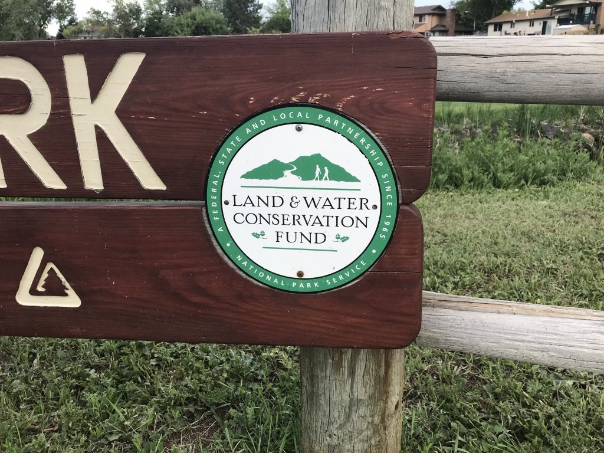
Public Availability
Project areas and facilities must be available for public use at reasonable hours and times of the year, according to the type of area or facility. Some areas or facilities may be reserved at certain times for school use (or use by other organizations). At such facilities, the project sponsor is required to install and maintain a sign to indicate public availability.
Sign specifications and examples are provided in the Appendix.

Application and Evaluation Procedures

Priority Rating System
Complete applications received by the Oklahoma Tourism and Recreation Department by 4:00 P.M., on March 31st, 2026, will be reviewed by this office and ranked using the Priority Rating System. The Priority Rating System is included in the Appendix to assist project sponsors in preparing applications to achieve their highest possible scores.
This period of review and ranking will take place within the first few weeks following the application deadline.

Appropriation and Pre-approval
After this office receives official notification of Oklahoma’s Land and Water Conservation Fund appropriation, the applications will be selected for recommended funding by this office according to their score. Recommendations will be sent to the OTRD Executive Director’s office for pre-approval and then submitted to the National Park Service for final approval.

Environmental and Cultural Resource Reviews
All projects must comply with Section 106 of the National Historic Preservation Act, along with all local, state, and tribal rules and regulations. Upon receiving State pre-approval, the project sponsor will be required to submit state environmental review documentation relating to the project to the Oklahoma Department of Tourism and Recreation. OTRD will submit documentation to the Oklahoma Archeological Survey, the Oklahoma State Historic Preservation Office, and to NPS for consultation with the Tribal Historic Preservation Offices. Project sponsors will not at any point contact OAS, SHPO, or THPO.
The project sponsor must complete cultural resource surveys (if required), resulting in SHPO/THPO concurrence. Tribal consultation will be completed by the NPS in cooperation with the OTRD.
The Oklahoma Tourism & Recreation Department will provide the forms for obtaining these reviews. Project applications will not be submitted to the National Park Service until the environmental reviews have been completed and clearance obtained.
For the purpose of completing Section 106 and NEPA review, please refrain from conducting any ground-disturbing activities at the project site until all regulatory review is complete. Any ground-disturbing activities conducted prior to application submission and a formal project agreement may result in disqualification from the Land and Water Conservation Fund grant program or cause significant delays in the review timeline.

Inspections
Once the proposed project has received environmental clearance, OTRD staff will conduct a pre-award inspection of the project site.
Note: A minimum of two more inspections will be conducted over the course of an approved project period. OTRD staff will conduct an inspection when a project is approximately 50% complete. A final inspection will also be required before the final reimbursement of funds is processed.

National Park Service
After all State reviews and inspections have been completed with positive results and all necessary documentation has been obtained, tentatively approved project applications will be forwarded to the National Park Service Regional Office for federal review and approval.

Sponsor Agreement
Once the National Park Service provides official notice to our office that a project application has been approved, we will prepare an agreement between OTRD and the project sponsor.
The agreement will include the scope of the project and the project period. Any additional documents or forms needed specific to the project will also be obtained.
After all required documents are on file in this office and both parties have signed the agreement, the project sponsor will receive official notice to begin work on the project.
Any project expenses incurred or paid by the sponsor before the Sponsor Agreement is signed by both parties will not be eligible for reimbursement or project match.

LWCF Project Application
Project Sponsors, please read all instructions thoroughly. All items are required as part of your application. Incomplete applications will not be considered for LWCF funding. The application can be downloaded as a Microsoft Word document or Adobe PDF. You can find the application at https://otrd.travelok.com/land-and-water-conservation-fund/
Complete your application in the order of the sections below and submit as a separate document.
- Project Sponsor Information
- Project Cost
- Project Site Information
- Project Narrative
- Detailed Project Description
- Application and Revision (A&R Form or Form 10-904)
- LWCF Project Timeline
- Separate Attachments
Answer all questions as completely and clearly as possible. Do not assume those reviewing your application will have any prior knowledge or information. The review committee may include individuals who are not familiar with you or your area.
Organize your application folder using the format below.

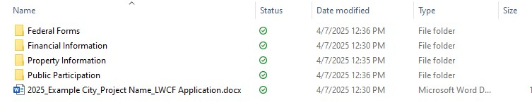
- Federal Forms - Contains only the federal forms attachment provided on the OTRD grants website.
- Financial Information – Contains the cost estimate provided on the OTRD grants website, engineer cost estimates and quotes, budget resolution, 5-year maintenance plan and budget documentation, funding certification provided by OTRD, and documentation of supplemental funds (if applicable).
- Property Information – Contains property deed, , project 6(f)(3)-boundary map, project location map, project site map/development plan, and floor plans (if applicable). Title insurance and title opinion (acquisition grants only). Flood plain map and proof of insurance if project is located within the floodplain.
- Public Participation – Contains documentation of public support such as surveys, meeting minutes, letters of support, etc.

Financial Profile and Property Information

Cost Estimate and Sponsor’s Matching Share
Provide documentation that shows the minimum required 50% local match for the project is readily available. Include tables detailing the sources and uses of funding, including line-item expenses. An example is provided in the Appendix. The cost estimate template can be downloaded from the OTRD grants page as a Microsoft Excel spreadsheet.
Use the format provided and sign and date.
The following is a list of methods by which the local share of a project may be financed. You may use one or a combination of these methods:
  - Donated Cash – Strictly monetary contributions. Project sponsors will be required to provide documentation (invoices, etc.) on how the money was used when requesting reimbursement.
  - Donated Land – Strictly the donation of real property by a non-public entity. Land must be appraised according to LWCF guidelines. Do NOT take title prior to project approval or the land value will NOT be eligible for reimbursement.
  - Donated Equipment/Materials – The actual items are donated for permanent ownership.
  - Donated Labor and/or Equipment Use – Donated labor is an estimated value of unpaid labor performed by volunteers on the project based on the wage scale of the job performed. Donated equipment use is the estimated value of donated equipment to be used on the project, based on FEMA hourly-use rates.
  - Land Acquisition – The purchase of real property. Land must be appraised according to LWCF guidelines. Do NOT take title prior to project approval or the land value will NOT be eligible for reimbursement.
  - Cash Financing – The purchase of equipment or materials, hiring paid labor, or contracting for work performance by a private business.
  - In-Kind Labor and/or Equipment Use – In-Kind Labor is the estimated value of the wages to be paid to the sponsor’s employees for work on this project.
In-Kind Equipment Use is the estimated value of sponsor-owned equipment to be used on the project, based on FEMA hourly-use rates.

Land Ownership
To ensure the sponsor has control and tenure of the site, the sponsor is required to submit a copy of the Title or Deed.
For acquisition or combination projects, only a Certificate of Title is necessary at the time of application. After state and federal approval and acquisition by sponsor, an updated Title will be required.

Location Map
Provide an aerial map of the city and county showing the geographic location of the proposed project. Identify Park boundaries and areas of potential effect. The location map should include these identifiers:
- Location of site
- Entrance to site
- Street Address (Should match address on all other forms and maps)
- Main Entrance Coordinates
- Location of Site within State and County
- Area of Potential Effect
For Example Purposes:
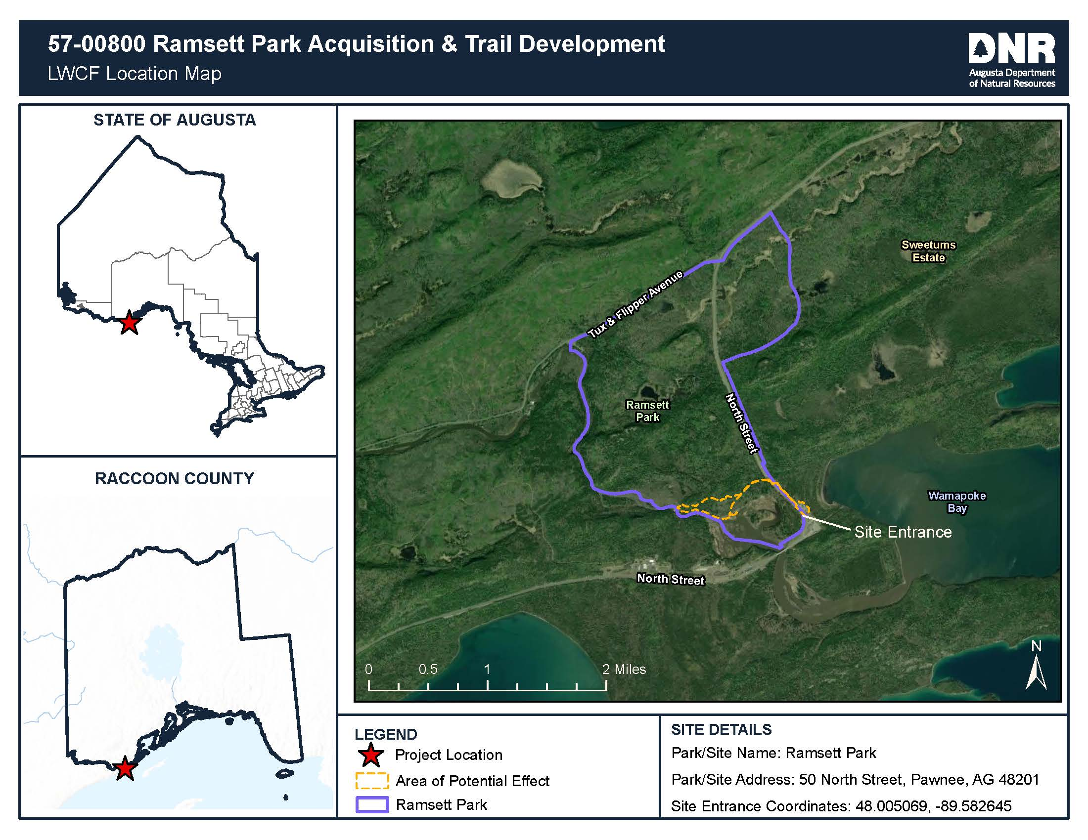

Project 6(f)(3) Boundary Map
The project boundary map is one of the most important components of the project proposal. If the boundary map does not match the deed, please include an explanation.
When acquiring property with federal funds, the boundary map and deed must match.

Please follow these instructions for creating a map of 6(F)(3).
  - When applying for an LWCF grant, project sponsors must submit a signed and dated project boundary map that clearly delineates the area to be protected under Section 6(f)(3) of the LWCF program. Land identified within the Section 6(f)(3) boundary must be retained in perpetuity for public outdoor recreation use.
  - Generally, this area includes the entire park or project area where recreation is being developed, except in unusual cases where it can be shown that a facility within an area is clearly self-sustaining (and accessible) without reliance on the surrounding area. The project area must be readily accessible through a public corridor (i.e., parking lot, street, permanent public easement, etc.).
  - Maps should be no bigger than 11” x 17”.
  - Maps may be drawn on a satellite or aerial image.
  - Full-color images are preferred.
Use the checklist on Page 16 to ensure all the required elements have been included on your 6(f)(3) boundary map. Refer to the boundary map template on Page 17 that shows a numeric legend of the corresponding elements. The numeric legend is provided only as a reference to help identify each element and does not need to be reproduced on the boundary map you submit with your application.

Site Map Conceptual
The site map conceptual should show the following:
- Existing facilities, including all utility lines and ROW’s
- Lighting
- Accessible parking spaces and walkways.
- Any proposed facilities to be included in this project (Existing and proposed facilities should be clearly defined)

Floor plan
Floor plans for all proposed support buildings (restrooms, shelters, etc.) must be submitted and clearly indicate accessibility compliance.

Checklist – Creating a 6(f)(3) Boundary Map

- Title the map as “Section 6(f)(3) Boundary Map.”
- Include the name of the park, site, or project.
- Include a north arrow.
- Provide a signature and date on the map by the individual authorized in the resolution.
- Include the date of the map preparation.
- Clearly indicate dimensions of the project area with measurements in feet on each side to effectively illustrate the area that will be under Section 6(f)(3) protection. The map needs to indicate entrance/access point(s).
- If applicable, identify any pre-existing uses (buildings/non-outdoor recreation facilities) that do not support outdoor recreation and that should be excluded from 6(f) protection. Include the square footage of the non-supporting facility or area footprint. Subtract this square footage from the total square feet of the area to be protected under 6(f).
- If applicable, include any area or resource upon which the project is dependent, even if the area/resource was not included in the project scope. An example of this would be an existing parking lot that provides the sole access to a picnic area that is being developed with an LWCF grant. The parking lot would need to be included in the
6(f) boundary and its footprint added to the total square footage.
- If applicable, indicate any outstanding rights and interests in the area, including easements, deed/lease restrictions, reversionary interests, rights-of-way, utility corridors, etc.
- Indicate adjacent street names, bodies of water and any other features that could be used as identifying landmarks.
- If applicable, indicate any areas under lease with a term of at least 25 years remaining on the lease.
- Indicate assessor’s parcel number(s).
- Provide the latitude and longitude of the project entrance.
- If applicable, indicate the location of the development/renovation project in relation to existing facilities.
- Convert the total square footage to acreage and indicate total acreage within the 6(f)(3) boundary. The acreage identified on the boundary map must be consistent with the acreage identified in Question 12 on the application form.

Example – 6(f)(3) Boundary Map

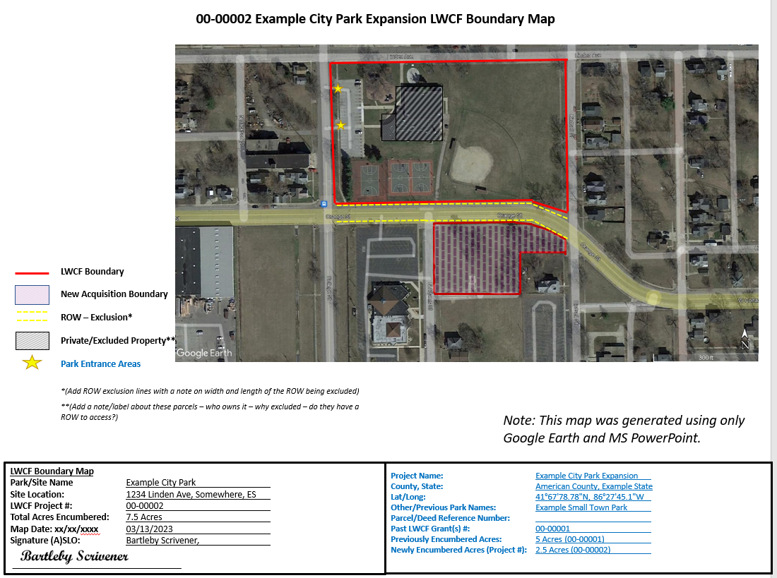

Notices

Paperwork Reduction Act Statement
In accordance with the Paperwork Reduction Act (44 U.S.C. 3501), please note the following. This information collection is authorized by the Land and Water Conservation Fund Act of 1965 (54 U.S.C. 200301 et.seq.). Your response is required to obtain or retain a benefit. We use this information to obtain descriptive and environmental information about a proposed grant project or revision. We may not conduct or sponsor, and you are not required to respond to a collection of information unless it displays a currently valid Office of Management and Budget control number. OMB has assigned control number 1024-0031 to this collection.

Estimated Burden Statement
Completion times vary depending on the use of this form. We estimate that the average completion time for this form is 16 hours for an application and 3 hours for an amendment, including the time necessary to read, gather data, review instructions, and complete the form. Send comments regarding this burden estimated or any other aspect of this collection of information, including suggestions for reducing this burden, to:

Information Collection Officer | National Park Service
12201 Sunrise Valley Dr | MS-242 RM.2C114 | Reston, VA 20192 Please do not send your completed form to this address.

Supplemental Attachments
Complete and sign each of the forms on the federal forms attachment and submit as an attachment to your application.
- Application Certification
- Minority Business Enterprise
- Participating Agencies
- Civil Rights Assurance
- National Historic Register
- Debarment and Suspension (2)
- Accessibility Compliance
- Consultant Form (If Applicable)
- Reimbursement Assurance
- Build America Buy America

In addition to the forms provided, please include the following as separate attachments:

- Documentation of Public Hearing
- Financial Profile Information
  - Cost Estimate
  - Line-Item Expenses
  - Budget Resolution
  - 5-Year Maintenance Budget Resolution
  - Funding Certification
  - Documentation of Supplemental Funds (if applicable)
    - Project agreements for other state grants
    - Signed donation commitment letters
- Property Information
  - Property Deed
  - Title Insurance, Title Opinion (Acquisition grants only)
  - Project 6(f)(3)-Boundary Map
  - Project Location Map
  - Project Site Map/Development Plan
  - Floor Plan (if applicable)

For a detailed description of the scoring metric, please see the Open Project Selection Process (OPSP) found on the OTRD Grants Website at Land and Water Conservation Fund (LWCF) - Oklahoma Tourism and Recreation Department

Section 3 Question F references the A&R form included as part of the application.

Example – cost estimate

Source of Funds | Grant Request | Cash Match | In-kind Match | Donate Match | Totals
LWCF GRANT | $ 990,000.00 |  |  |  | $ 990,000.00
SPONSOR |  | $ 990,000.00 |  |  | $ 990,000.00
OTHER CONTRIBUTORS |  |  |  |  | $ -
 |  |  |  |  | $ -
 |  |  |  |  | $ -
 |  |  |  |  | $ -
 |  |  |  |  | $ -
TOTALS |  |  | $ - | $ - | $ 1,980,000.00

Use of Funds |  |  | In-kind Match | Donate Match | Totals
I. PROFESSIONAL SERVICES |  |  |  |  | $ -
 |  |  |  |  | $ -
I. a. Design and Engineering |  |  |  |  | $ -
I. b. Administrative Fees |  |  |  |  | $ -
II. PROJECT MATERIALS |  |  |  |  | $ -
Pavilion | $ 100,500.00 | $ 100,500.00 |  |  | $ 201,000.00
Benches | $ 10,000.00 | $ 10,000.00 |  |  | $ 20,000.00
Picnic Tables | $ 5,000.00 | $ 5,000.00 |  |  | $ 10,000.00
Playground Equipment | $ 200,000.00 | $ 200,000.00 |  |  | $ 400,000.00
Parking Lot Materials | $ 185,000.00 | $ 185,000.00 |  |  | $ 370,000.00
Playground Surfacing | $ 60,000.00 | $ 60,000.00 |  |  | $ 120,000.00
Sidewalk Materials | $ 10,000.00 | $ 10,000.00 |  |  | $ 20,000.00
 |  |  |  |  | $ -
 |  |  |  |  | $ -
 |  |  |  |  | $ -
III. PROJECT CONSTRUCTION |  |  |  |  | $ -
Parking Lot | $ 90,000.00 | $ 90,000.00 |  |  | $ 180,000.00
Turf Reinforcement - drainage | $ 6,000.00 | $ 6,000.00 |  |  | $ 12,000.00
Volleyball Court | $ 4,500.00 | $ 4,500.00 |  |  | $ 9,000.00
Concrete Sidewalk | $ 50,000.00 | $ 50,000.00 |  |  | $ 100,000.00
Concrete Header Curb | $ 8,050.00 | $ 8,050.00 |  |  | $ 16,100.00
Mobilization/Construction | $ 70,000.00 | $ 70,000.00 |  |  | $ 140,000.00
Staking | $ 6,500.00 | $ 6,500.00 |  |  | $ 13,000.00
Surfacing - install/underdrain | $ 20,000.00 | $ 20,000.00 |  |  | $ 40,000.00
Playground -build/install | $ 72,800.00 | $ 72,800.00 |  |  | $ 145,600.00
III a. Demolition |  |  |  |  | $ -
Sidewalk and Curb Removal | $ 900.00 | $ 900.00 |  |  | $ 1,800.00
III b. Site Work | $ 90,750.00 | $ 90,750.00 |  |  | $ 181,500.00
 |  |  |  |  | $ -
IV. LAND DONATION |  |  |  |  | $ -
 |  |  |  |  | $ -
TOTALS | $ 990,000.00 | $ 990,000.00 | $ - | $ - | $ 1,980,000.00

LWCF Project Timeline Template Example

Project Name___________________

Contact Person____________________

Contact Information ___________________________

Proposed Start Date and Completion Time for Major Milestones

Project Phase | Start Date | Time to Complete (In Weeks)
Design and Engineering | April 1, 2025 | 12 Weeks
Secure Permits | July 1, 2025 | 1 Week
Award Bids | July 10, 2025 | 4 Weeks
Site Work | Estimated August 5, 2025 | 12 Weeks
Purchasing | November 8, 2025 | 12 Weeks for procurement
Construction | February 5, 2026 | 20 Weeks with contingency for weather
Install | July 8, 2026 | 4 Weeks
Punch List Items | August 10, 2026 | 4 Weeks
Grant Closeout Documents | September 10, 2026 | 4 Weeks

Project Sponsor Signature______________________________________
Sign Specifications and Examples

Minimum Location / Placement
A Land and Water Conservation Fund acknowledgement sign must be posted at all project-funded sites to recognize that Land & Water Conservation Funding was used for the project development and /or acquisition. These signs should be posted at the main entrance to the facility.

Design Instructions
The LWCF acknowledgement sign must include the following design. Costs related to project signs, school-use signs, directional, informational and handicap accessibility signs, are allowable for reimbursement as part of the initial capital investment.
If you prefer, the following vendor can be contacted for ready-made LWCF acknowledgement signs at minimal cost:
Oklahoma Correctional Institute (OCI) OCI Customer Service: 1.800.522.3565 www.ocisales.com

Sites and Facilities Operation and Maintenance
Pursuant to Section 6(f)(3) of the LWCF Act and 36 CFR59.3, Chapter 8 of the LWCF Manual contains the requirements for maintaining LWCF-assisted sites and facilities in public outdoor recreation use following project completion and to assure that LWCF-assisted areas remain accessible to the public, including non-residents of assisted jurisdictions. These
post-completion responsibilities apply to each area or facility for which LWCF assistance is obtained, regardless of the extent of participation of the program in the assisted area or facility.
Property acquired or developed with LWCF assistance shall be operated and maintained as follows:
- The property shall be maintained so as to appear attractive and inviting to the public.
- The sanitation and sanitary facilities shall be maintained in accordance with applicable health standards.
- Properties shall be kept reasonably open, accessible, and safe for public use. Fire prevention, lifeguards, and similar activities shall be maintained for proper public safety.
- Buildings, roads, trails, and other structures and improvements shall be kept in reasonable repair throughout their estimated lifetime to prevent undue deterioration and to encourage public use.
- The facility must be kept open for public use at reasonable hours and times of the year, according to the type of area or facility.
- A posted LWCF acknowledgement sign shall remain displayed at the project site pursuant to Chapter 7 of the LWCF Manual.

Availability to Users
- Under Title VI of the 1964 Civil Rights Act, property acquired or developed with LWCF assistance shall be open to entry and use by all persons regardless of race, color, or national origin, who are otherwise eligible. Discrimination is also prohibited on the basis of religion or sex.
- Section 504 of the Rehabilitation Act of 1973 requires no qualified person shall, on the basis of disability, be excluded from participation in, be denied benefits of, or otherwise be subjected to discrimination under any program or activity that receives or benefits from federal financial assistance.

Penalties for Non-compliance
If a project sponsor fails to comply with the regulations governing this program and does not take appropriate remedial actions, obtaining future federal or state funding may be compromised.
For further explanation of post-completion requirements, refer to the LWCF Manual:
nps.gov/subjects/lwcf/lwcf-manual.htm

